**Hopping Out of Time: High Concept ⏳**

🐸 *“Lost in magical time”* 🐸

# 1 What is Hopping Out of Time?

*Hopping Out of Time* is a puzzle/platformer-style game that requires skillful navigation (platforming). The game entails a Whimsy mystical theme (Silly Wizards) set in a 2D environment. The goal of the game is to navigate to the top of one large wizard tower level filled with wacky and unconventional out-of-control experiments. The experiments will challenge the player’s journey to the top of the tower, which they must reach before time runs out.

## 1.1 The Main Concept

The main concept of the game is to create an unconventional platformer which forces the players to focus on using skills such as memorization, exploration, and experimentation to navigate and clear a path to the top of the wizard tower.

The game’s narrative revolves around a clumsy little apprentice wizard whose experiments go wrong causing a magical artifact to be smashed (see figure 1 for visual of wizard). The wizard’s accident causes it to be sent back in time and space to the bottom of their tower. The nature of the artifact causes time loops; thus, the wizard must race against time climbing their maze-like tower, full of wacky experiments and magical effects. Players will be able to collect powers along the way to help the wizard navigate back to the top, to stop the artifact from breaking before the time loop sends the wizard back to the bottom once again.

## 1.2 The Game Goals and Style

## The game’s setting will be in a whimsical, colorful wizard tower. The game’s background, as well as the other assets will be created in a 2D pixel art style to convey the whimsical and fun nature of the game. It will also help reflect the fantasy/adventure style of the game. The goal of the game will be simple and clear, which is to reach the top of the tower before time runs out. The player will be able to control the characters’ every movement, as well as its powers to create a game of navigation mixed with puzzle-solving. More specifically, the game will have a semi-sandbox approach to progression, where navigation ‘puzzles’ can be solved with creative use of different powers

## 1.3 Who can Play the Game?

People with previous experience in gaming, or people with awareness of the conventional platformer-style game. Ideally, the game will have a difficulty curve like that of the original *Super Mario Bros*. platformer. So, the early stage of gameplay will be straightforward with simple/conventional mechanics. However, as the player progresses, the gameplay adds layers of unconventional navigation puzzles and paths that ramp up the game’s complexity.

## 1.4 The Main Conflict

The major conflict in the game is the player’s race against time. The player needs to reach the top of the tower before the game loops them back to the very beginning. Thus, with each loop iteration, the player will have learned the position of items that grant various powers, which ones to go for first to navigate the levels more effectively. As a result, the looping nature of the game breeds experimentation of routes to take and ability usage.

The minor conflict of the game will pertain the obstacles and the puzzles that the player needs to overcome to reach the top of the tower. The game will tie weird and zany abilities will into the theme of wacky magical wizards to help the player clear those obstacles. This will be reflected in the level geometry and environmental effects.

# 2 Game Design

## 2.1 The Main Mechanics

* The core mechanics of the game will 2D traversal. This means that navigation will mainly constitute the characters movement left, right, up, down, as well as jumping. However, the player’s collection of magical artifacts will allow to them to gain enhanced abilities that expands navigational options. Powers may include options such as dash, teleportation, telekinesis…etc.
* When the player obtains different magical artifacts, various magical abilities are added to their spell book / arsenal. The player can actively switch between powers to use them, and possibly chain their effects together.
* Various levels of the tower will have different themes and enchantment effects that will change the level geometry (dynamic effects such as moving platforms, certain abilities enhanced or disabled)

## 2.2 Levels

*Hopping Out of Time* will have a single vertically sprawling level (the wizard’s tower). The choice of a single level reflects how the goal is to make the gameplay last on the shorter side. The wizard’s tower will have sub-sections that hold different themes and magical effects (see figure 2). The sub-sections will define the player clearing a certain stage of the game and moving on to more challenging or complex puzzles.

## 2.3 Gameplay

The main gameplay centers a little wizard which the players can control to jump, glide, run, teleport, manipulate objects and states of matters. The wizard will navigate through various levels of a tall wizard's towers that contain various magical effects that affect traversal and gameplay.

At the beginning of the game the player finds themselves at the bottom of the tower with multiple paths available to them, they will explore these paths by moving and jumping between moving platforms (themed as bookshelves and other wizard themed objects), navigating jumping puzzles and platforming challenges to reach various rooms in the wizard’s tower.   
 These rooms will contain a multitude of magical artifacts, when collected these artifacts will grant the player (wizard) different magical powers, such as a short dash, or teleport, the ability to manipulate objects such as moving them or freezing them from the effects of gravity. These powers will aid the player to navigate the more challenging puzzles they face higher in the tower.   
 Eventually the player will run out of time, time will be reset and rewound back to the beginning. The player will have learned what content is down a certain path, how to navigate that path more effectively and hopefully be able to complete this path faster.

# 3 Game Features

## 3.1 Key Game Features

Wacky wild wizard gets sent back in time through an experiment gone wrong.

Can you help the frog wizard navigate their out-of-control wizard’s tower and reach the zenith to prevent the wizard’s future self from causing the infernal time loop, where they find themselves stuck in?

Features:

* Single Player Game
* PC compatible
* Adventure fantasy game
* Explore a Whimsical tower
* Play as an unconventional fun wizard
* Gain magic abilities
* Solve mysteries and puzzles
* Race Against Time

# 4 Summary *Hopping Out of Time* is a fresh take on platformers, which centers the focus more on exploration rather than linear forms of navigation. It entails a fun experience, where the race against time components grabs the player’s attention and sucks them into the gameplay.

Appendix: Concept Art

**Figure 1.**

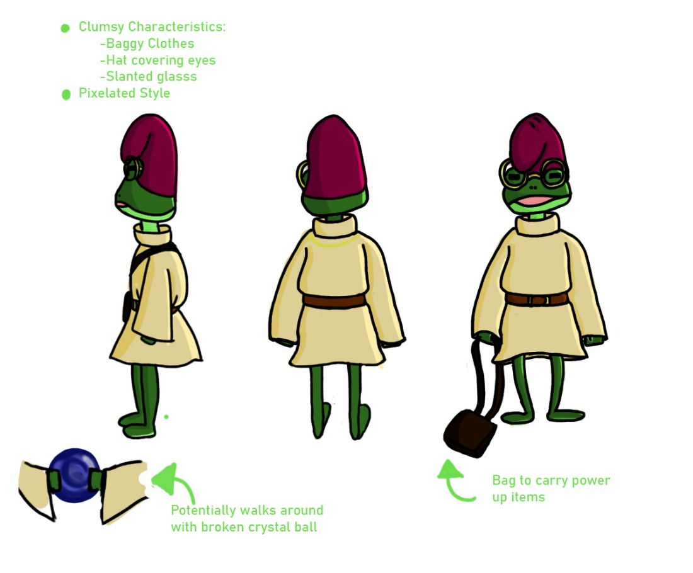

*Note: Character design of the frog wizard apprentice*

**Figure 2.**

*Tower design, showing different sub-sections of the single level*